

**Production scheduling of**

**‘The Hardee Toy Company’**

DS414 – Multi-Objective Programming

BY

محمد صافي أحمد شحاتة

20170237

اشراف ا. د. طارق أبو العينين

2021م

Table of contents

Introduction 3

The problem 4

The Model 5

- Objective Functions: 5

- Constraints: 5

The Algorithm: Goal Attainment Programming method 6

The Solution 7

The Conclusion 10

References 11

# Introduction

Multi-objective optimization (also known as multi-objective programming, vector optimization, multi-criteria optimization, multi-attribute optimization or Pareto optimization) is an area of multiple criteria decision making that is concerned with mathematical optimization problems involving more than one objective function to be optimized simultaneously.

Multi-objective optimization has been applied in many fields of science, including engineering, economics and logistics where optimal decisions need to be taken in the presence of trade-offs between two or more conflicting objectives.

Minimizing cost while maximizing comfort while buying a car, and maximizing performance whilst minimizing fuel consumption and emission of pollutants of a vehicle are examples of multi-objective optimization problems involving two and three objectives, respectively. In practical problems, there can be more than three objectives.

# The problem

The company manufactures two types of dolls ‘A’ and ‘B’. For each doll ‘A’ sold, the company makes $ 0.4 profit and for each doll ‘B’ sold, the company makes $ 0.3 profit.

Doll ‘A’ requires twice the time to manufacture as compared to that of doll ‘B’, If Dolls were of type ‘B’, The Company could make 500 per day.

Two objectives the company has are to maximize the profit and maximize the production of product ‘A’.

The raw material available for each day’s production of dolls ‘A’ and ‘B’ is limited to only 400.

In such a situation, the decision maker must specify the priority of his goals.

He may specify his first goal, to avoid the over usage of the raw materials, second to satisfy the closest customer by producing as many number of product ‘A’ as possible and the last priority is to maximize the profit as much as possible.

# The Model

* Decision Variables: Toy decisions with a decision variable for number of dolls of each type.
$$x_{i} i=1,2$$

* Objective Functions:

1. Max Profit: $Max f1\left(x\right)= 0.40x_{1} + 0.30x_{2}$
2. Max Product A: $Max f2\left(x\right)= x_{1}$

* Constraints:

1. material available for each day’s production:
$$g1\left(x\right)= x_{1} + x_{2}≤ 400$$

2. Twice:
$$g2\left(x\right)=2x_{1} +x_{2} ≤ 500$$

3. Non –ve:

$$x_{1}, x_{2} ≥ 0$$

# The Algorithm: Goal Attainment Programming method

Mathematically, multi-objective programming problem can be represented as:

$$Maximize \left[f1 \left(X\right), f2 \left(X\right), … , fk \left(X\right)\right]$$

𝑠𝑢𝑏𝑗𝑒𝑐𝑡 𝑡o

$$gi (X) ≤ 0, i = 1,2, … , m$$

Where 𝑋 is a 𝑛-dimensional decision variable vector. The problem consists of 𝑛 decision variables, 𝑚 constraints and 𝑘 objectives. Any or all of the functions may be nonlinear. In literature this problem is often referred to as a vector Maximum problem (VMP), or vector optimization problem (VOP).

The Goal Attainment Method requires that the DM gives a goal vector b and a vector of weight w relating the relative under or over attainment of the desired goals.

𝑀𝑖𝑛𝑖𝑚𝑖𝑧𝑒 Z

Subject to (2)

𝑔𝑗 (𝑋) ≤ 0, 𝑗 = 1, 2… 𝑚,

𝑓𝑖 (𝑋) − 𝑤𝑖𝑧 ≥ 𝑏𝑖, 𝑖 = 1, 2… 𝑘,

Where

∑|𝑤𝑖 = 1

Algorithm of the Goal Attainment Method Programming method:

1. Ask the DM to give a goal vector b.
2. Ask the DM to give a vector of weight w relating the relative under or over attainment of the desired goals.
3. Transform problem to the form of problem (2).
4. Solve the problem in step (3) using any suitable method (like the simplex method for linear programming).

# The Solution

Step 1:

The OM gives a goal vector b = (b1, b2) = (180, 200).

Step 2:

The OM gives a weight vector w = (w1, w2) = (-0.67, -0.33).

Step 3:

* Formulation of the new problem:

Min z

$$s.t. g_{1}\left(x\right)= x_{1}+x_{2} ≤400$$

$$g_{2}\left(x\right)= {2x}_{1}+x_{2} ≤ 500$$

$$0.4x_{1}+{0.3x}_{2}+ 0.67z ≥180$$

$$x_{1}+ 0.33z ≥200$$

$$x_{1},x_{2},z ≥0$$

Step 4: Solving the new problem using (dual simplex method):

* Iteration 1:

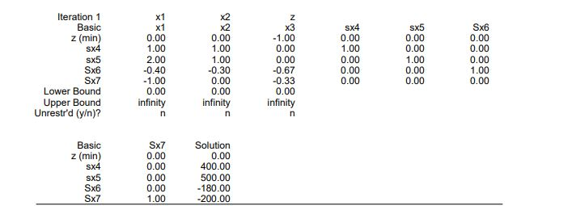

* Iteration 2:

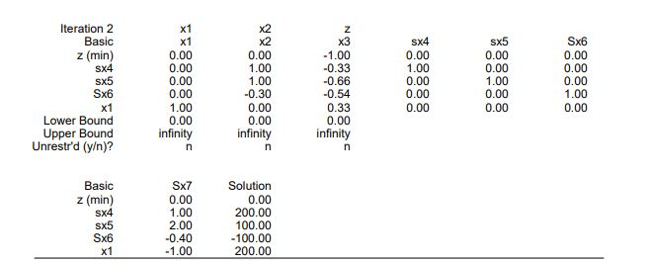

* Iteration 3:

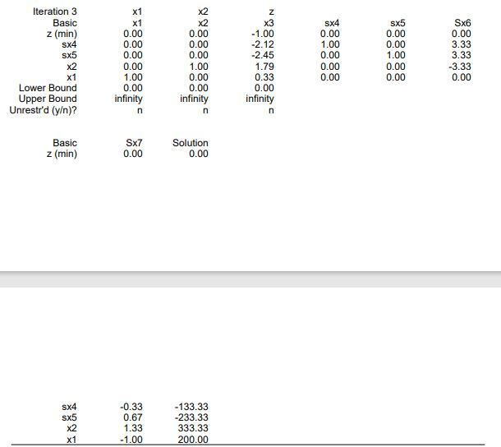

* Iteration 4: Optimal

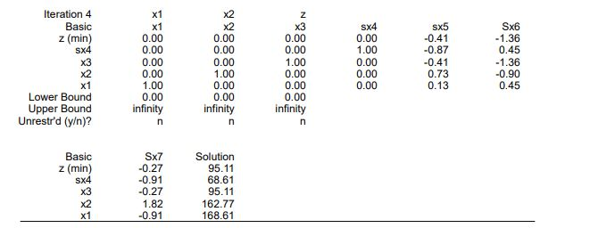

The Solution:

${x_{1}}^{*}=168.61$

${x_{2}}^{*}=162.77$

* Function(1)* = 116.27
* Function(2)* = 168.61

The Conclusion

As we got that the value of objective function (1) is equal to (116.27) which is not satisfied with its desired goal which is equal to (180) and the value of objective function (2) is equal to (168.61) which is not satisfied with its desired goal which is equal to (200).

So, we can now say that the base goal attainment method failed with this problem, we can improve it and get the results before asking the DM to give us the desired goals.

# References

* G.P.Liu, J.B. Yang & J. F. Whidborne (2003), “Multiobjective Optimisation and Control”, Research Studies Press LTD, Baldock, UK.
* Ching-Lai Hwang & Abu Syed Md. Masud (1979), “Multiple Objective Decision Making Methods and Applications”, Springer- Verlag, U.S.A.